***AWS IOT Framework***

***AWS IOT***: AWS IOT (Amazon internet of things) is basically an Amazon Web Services platform that gathers and studies data from devices connected to the internet and sensors and connects that data to AWS cloud applications.

***AWS IOT Core***is a managed cloud platform that lets connected devices easily and securely interact with cloud applications and other devices. AWS IOT can support billions of devices and trillions of messages, and can process and route those messages to AWS endpoints and to other devices reliably and securely. With AWS IOT, we can keep track of our applications and communicate with all our devices, all the time.

AWS IoT Core also makes it easy to use AWS and Amazon services like AWS Lambda, Amazon Kinesis, Amazon S3, Amazon SageMaker, Amazon DynamoDB, Amazon CloudWatch, AWS CloudTrail, Amazon QuickSight, and Alexa Voice Service to build IoT applications that gather, process, analyze and act on data generated by connected devices, without having to manage any infrastructure.

AWS IOT offers collect, store, and analyze IOT data for industrial, consumer, commercial, and automotive workloads.

 AWS IOT Core supports these protocols:

* [MQTT (Message Queuing and Telemetry Transport)](https://docs.aws.amazon.com/iot/latest/developerguide/mqtt.html)
* [MQTT over WSS (Websockets Secure)](https://docs.aws.amazon.com/iot/latest/developerguide/mqtt.html)
* [HTTPS (Hypertext Transfer Protocol - Secure)](https://docs.aws.amazon.com/iot/latest/developerguide/http.html)
* [LoRaWAN (Long Range Wide Area Network)](https://docs.aws.amazon.com/iot/latest/developerguide/connect-iot-lorawan.html)

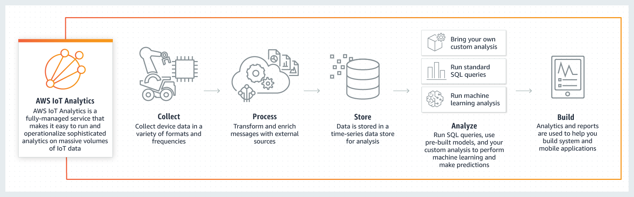

**AWS IoT Device Management** makes it easy to securely register, organize, monitor, and remotely manage IoT devices at scale. With AWS IOT Device Management, Registering your connected devices individually or in bulk, and easily manage permissions so that devices remain secure.

You can also organize your devices, monitor and troubleshoot device functionality, query the state of any IOT device in your fleet, and send firmware updates over-the-air (OTA)

